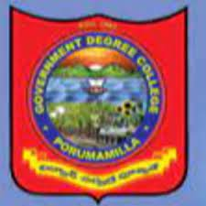

**GOVERNMENT DEGREE COLLEGE**

**PORUMAMILLA**

**HISTORY DEPARTMENT**

**POS**

**GOVERNMENT DEGREE COLLEGE, PORUMAMILLA.**

DEPARTMENT OF HISTORY

**(POS )**

With the goal of enabling students to gain a comprehensive knowledge and comparative Knowledge in History, the Department of History Government degree College, Porumamilla offers three- year undergraduate programs (B.A., H.E.P. & Honors) that span six semesters. The following skills will be acquired by students upon successfully completing the B.A. History Degree Program.

|  |  |
| --- | --- |
| **POs 1** | Students will have the ability to apply historical methods to evaluate critically the past and how historians and others have interpreted it. |
| **POs 2** | Students will be able to acquire basic historical research skills, including the effective  use of libraries, archives and data bases. |
| **POs 3** | Students will be able to organize and express their thoughts clearly and coherently  Both in writing and orally. |
| **POs 4** | Students will be able to demonstrate broad knowledge of historical events and periods  and their significance |
| **POs 5** | Students will be able to recognize how different individuals, groups, organizations,  societies, cultures, countries and nations have affected history. History gave the students wisdom and foresight for the future. |